Sreeraaghav Raja
1/27/26

EE Design 1 Technical Report
Power Supply Design

Introduction
The introduction should be one to two paragraphs and explain the goal(s) of the design module.

Methods
The methods section should include all background information needed for the design and steps used to create the results. Please cite any references used. Use subheadings as necessary.
Figures needed:
- LTSpice schematic for circuit with linear voltage regulator
- LTSpice schematic for circuit with switching regulator
- Pic of Breadboard (optional)

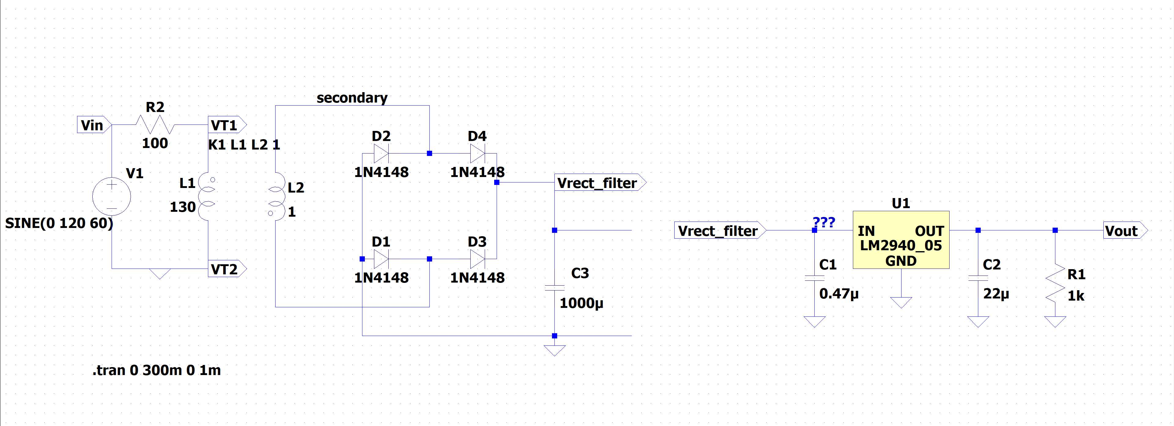
Figure 1: Image of Linear (LDO) Voltage Regulator
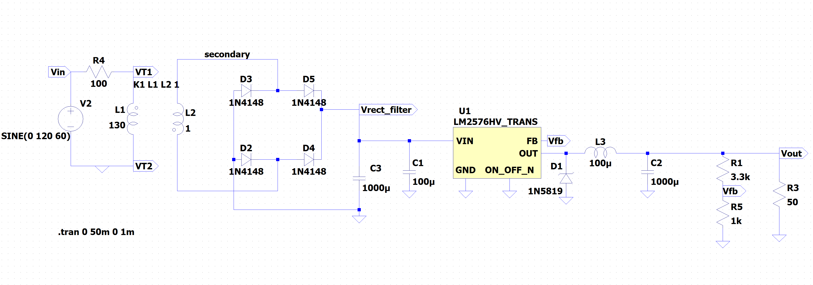
Figure 2: Image of Switching Voltage Regulator

Results
The results should be displayed in this section, which include figures and descriptive text for each figure. Figure captions need to be given as well, occurring below the figure. Use subheadings as necessary.
Figures needed: (make them neat and compact as possible with appropriate labeling)
- LTSpice Simulation Results:
    - Voltage at the output of each stage (i.e., transformer, bridge rectifier, filter, voltage regulator)
      - Use transient analysis and simulate enough time to let the initial transients dissipate
      - You have to detach some parts of the circuit to see rectifier and filter outputs.
- Breadboard Circuit Results:
      - 5V regulation at 5 mA for both regulators
      - 5 V regulation at 100 mA for both regulators
      - Noise data for both regulators at 5 and 100 mA
Discuss any discrepancies between simulation and measurement results.

Specific things to document and questions to answer in this section:
  - Peak/peak and rms noise and power efficiency for Linear Regulator at 5mA and 100mA load.
  - Peak/peak and rms noise and power efficiency for Switching Regulator at 5mA and 100mA load.
  - Do both supplies meet Voltage specs?
  - Which supply is more efficient? Under which current load?
  - Which supply is less noisy? Under which current load?

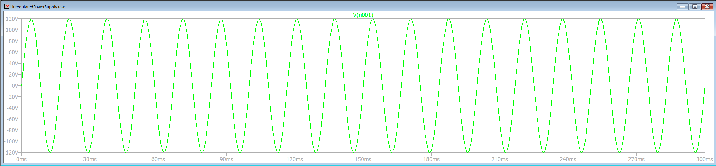
Figure 3: Input Voltage of Unregulated Voltage Circuit

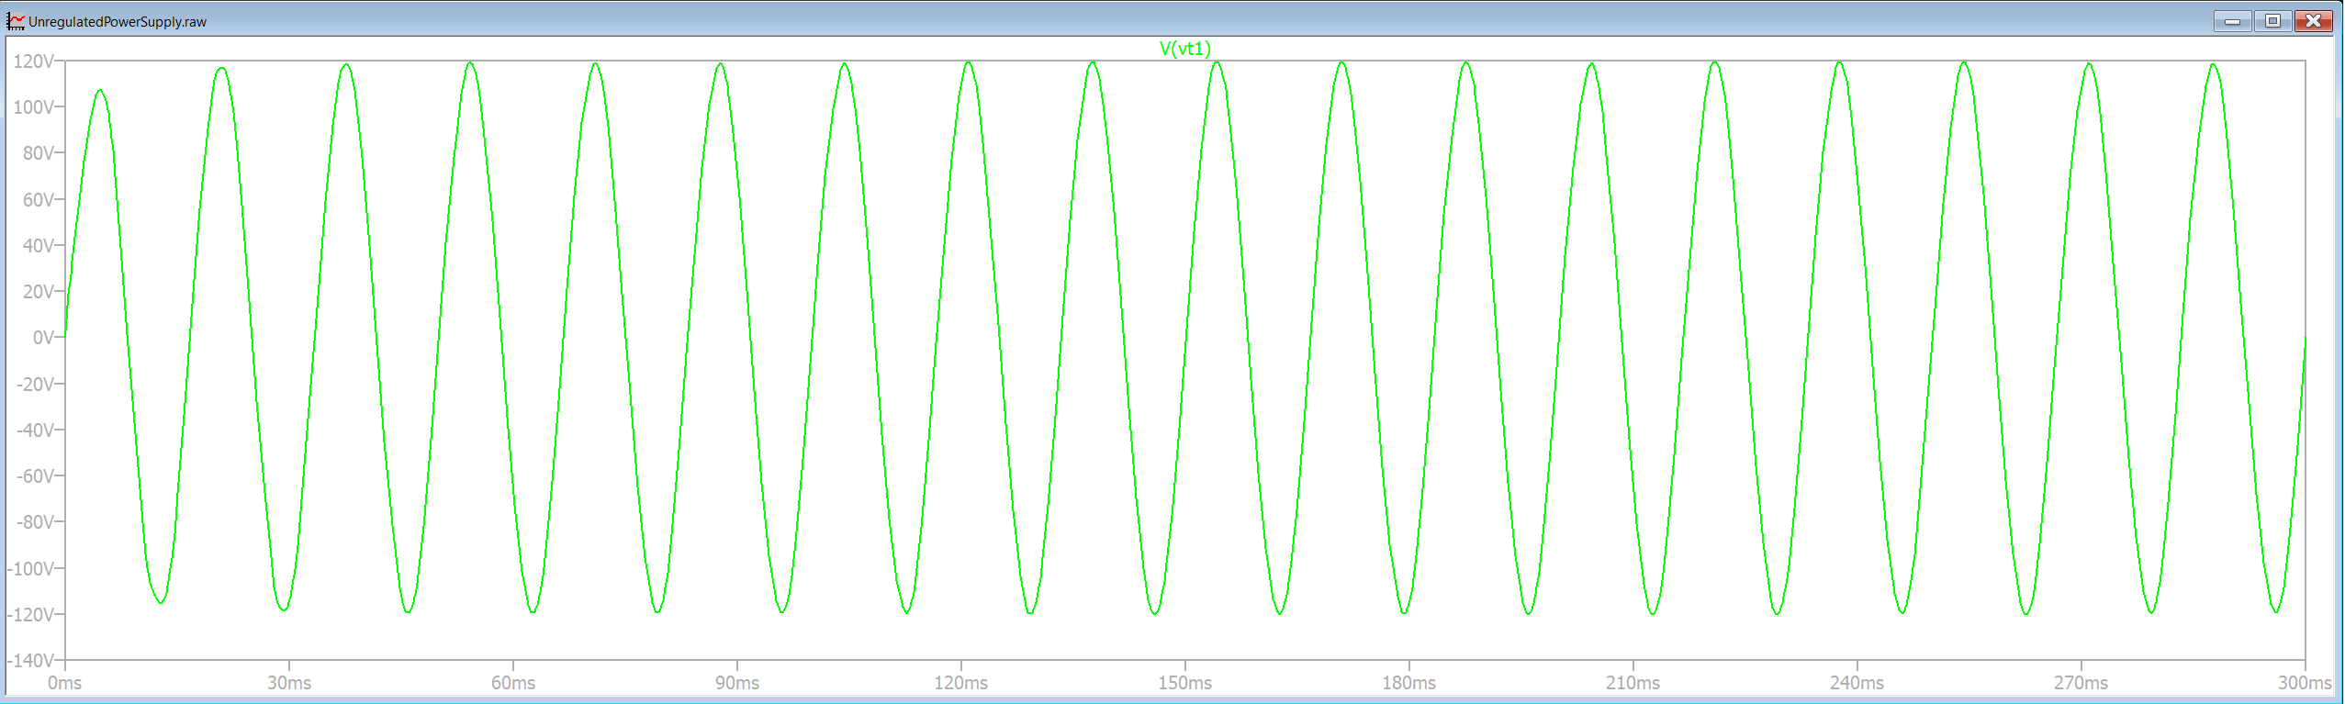
Figure 4: Simulation Output of Transformer Primary Stage

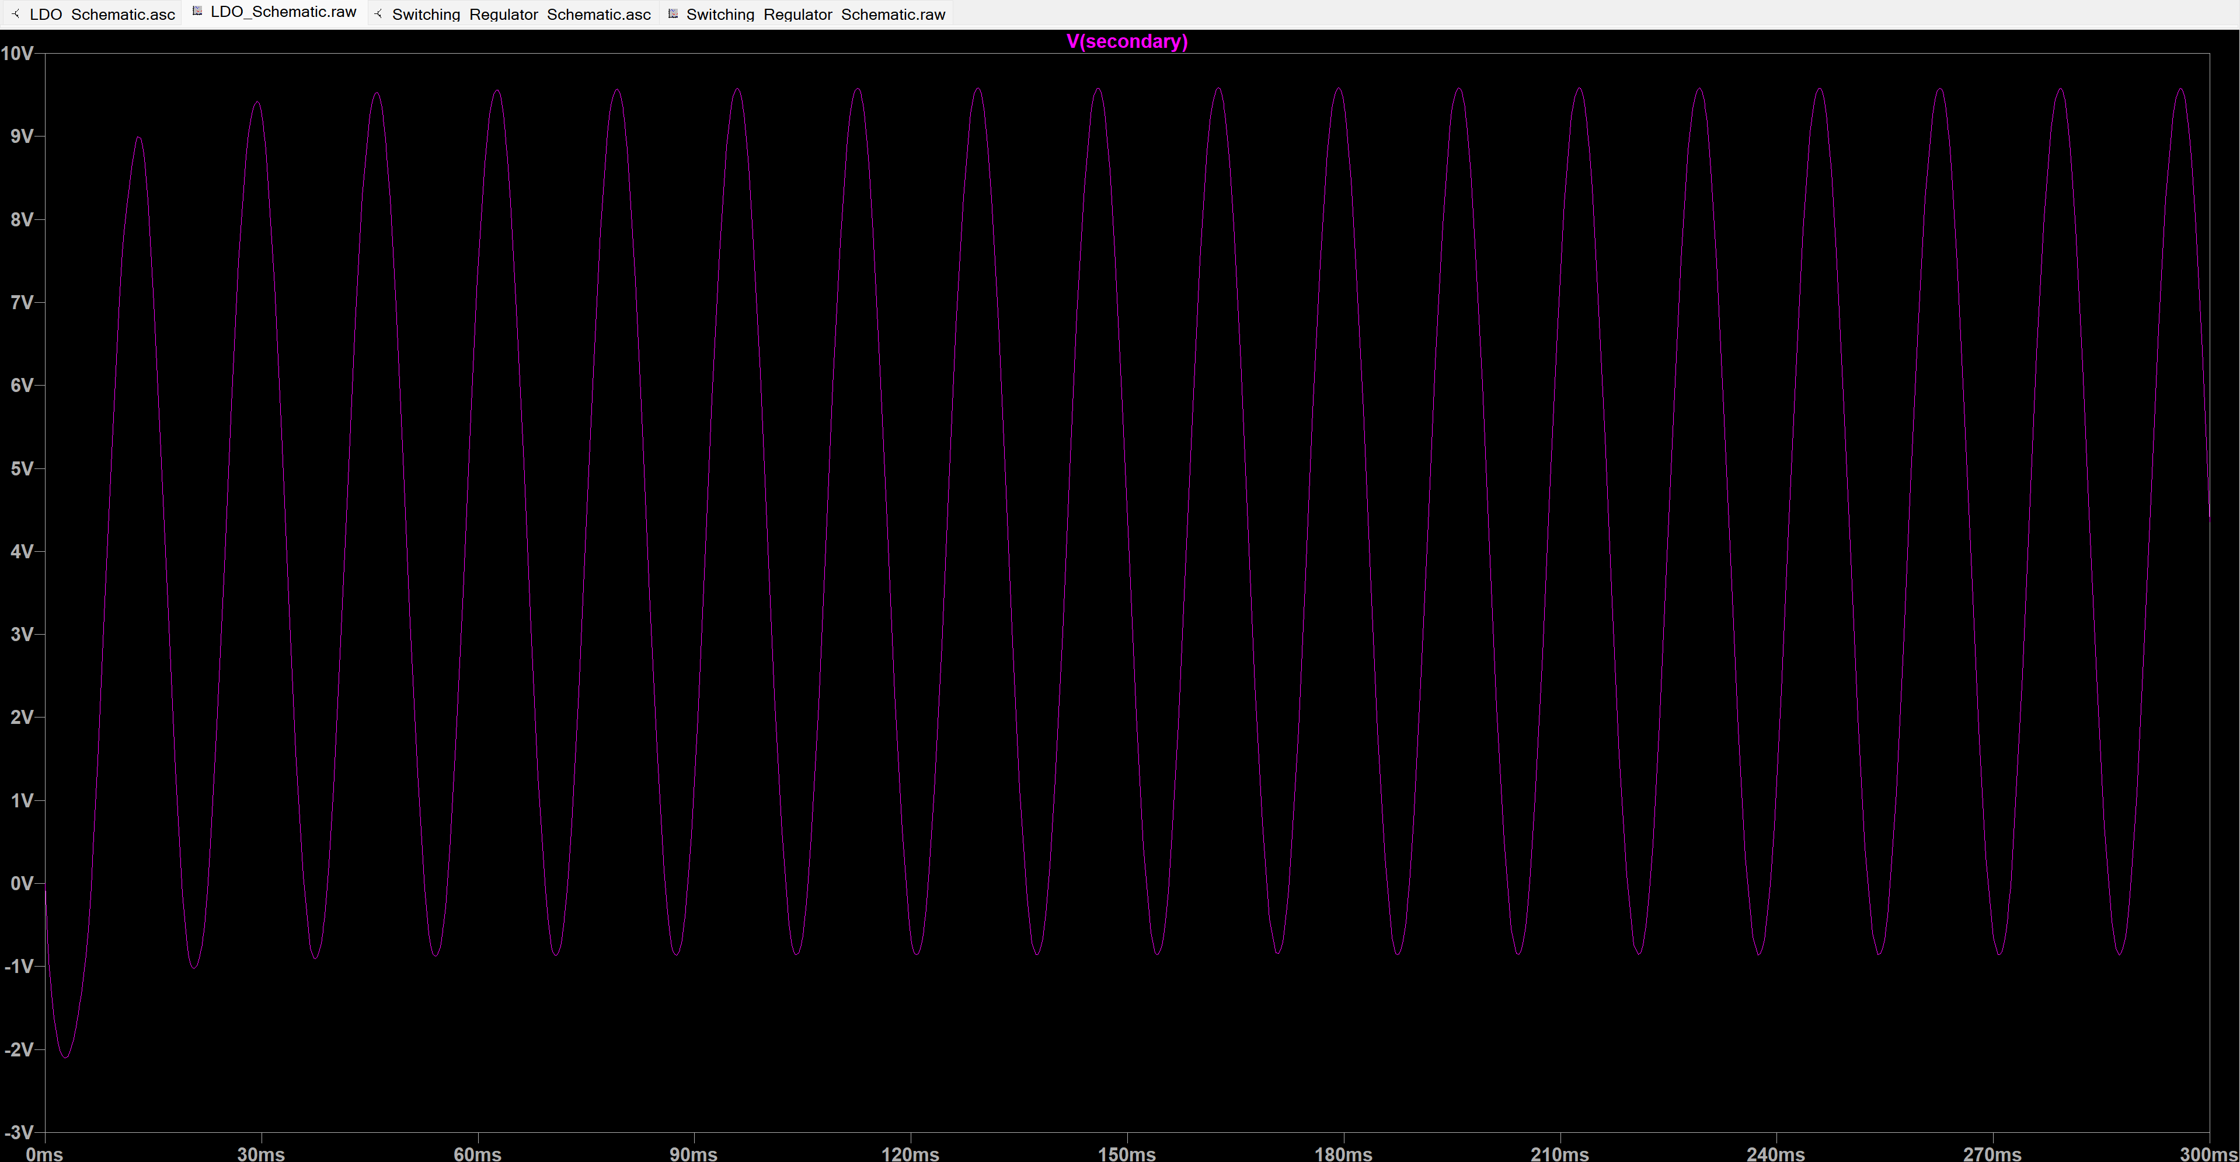
Figure 5: Simulation Output of Transformer Secondary Stage

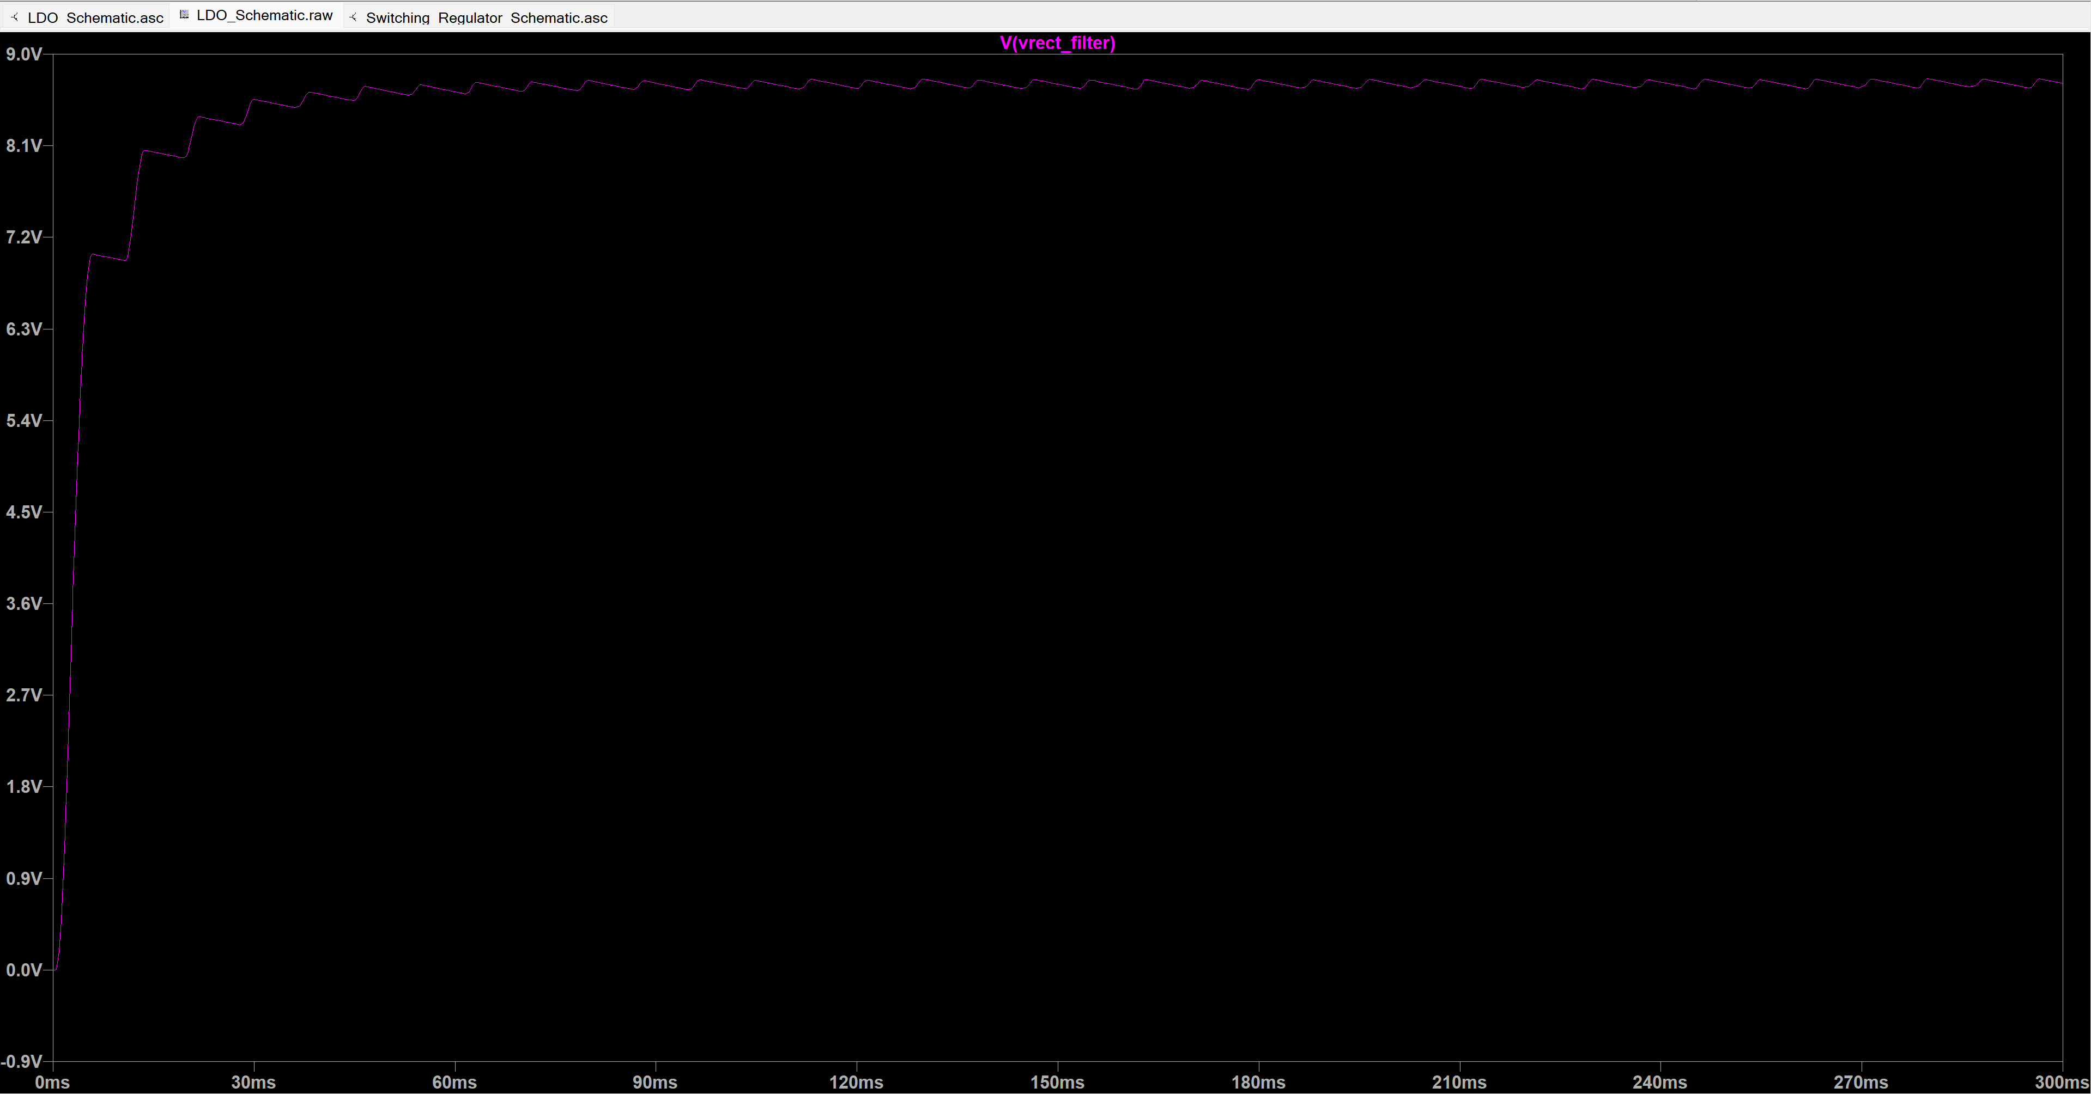
Figure 6: Unregulated Voltage Simulation Output (Rectifier and Filtering Stage)

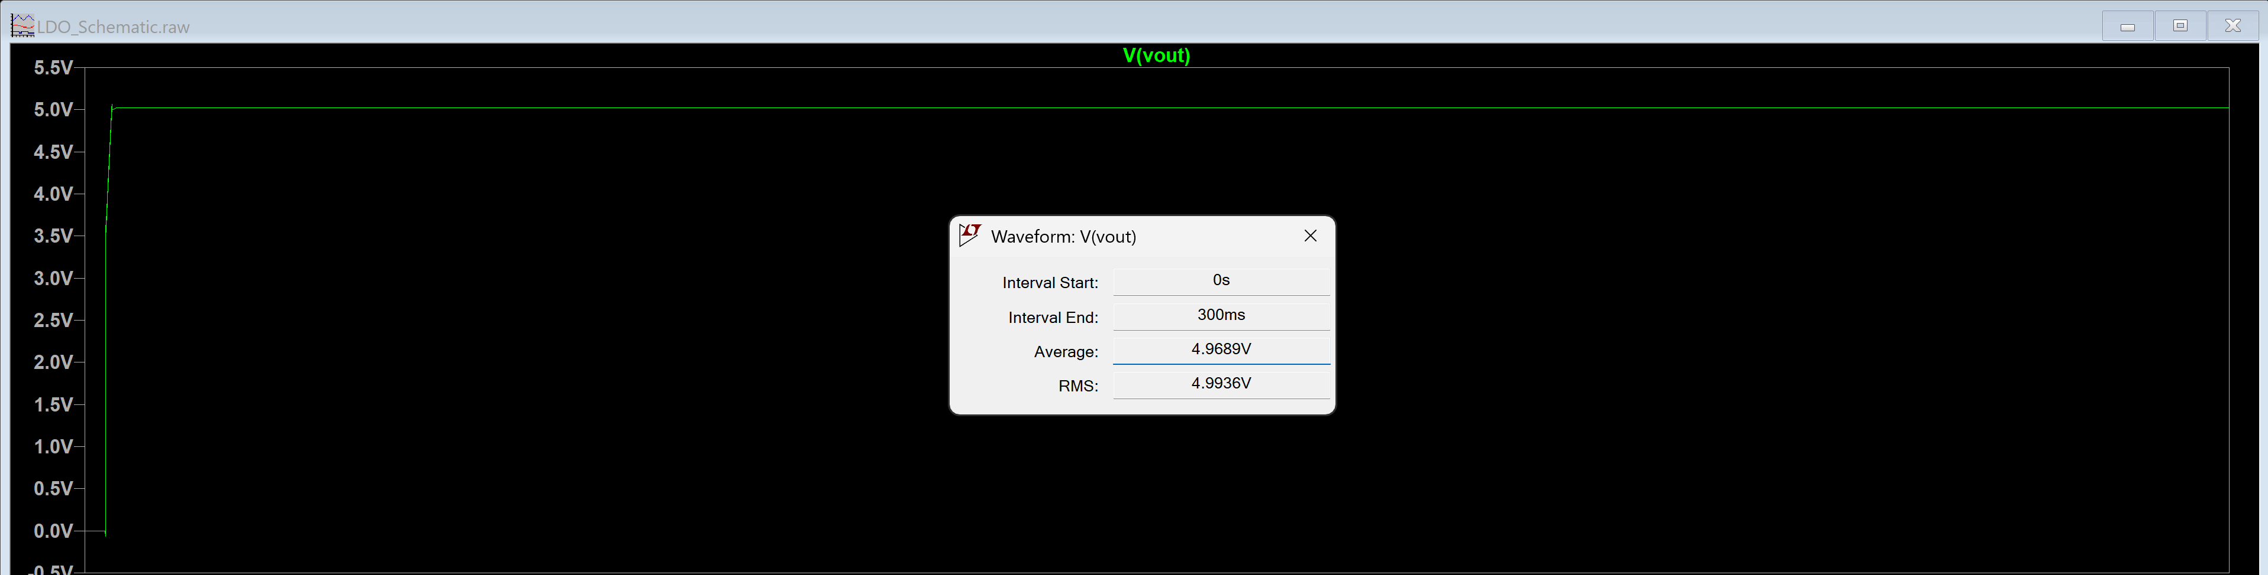
Figure 7: Regulated Voltage Output (LDO Output) of 100mA Output (Simulation)

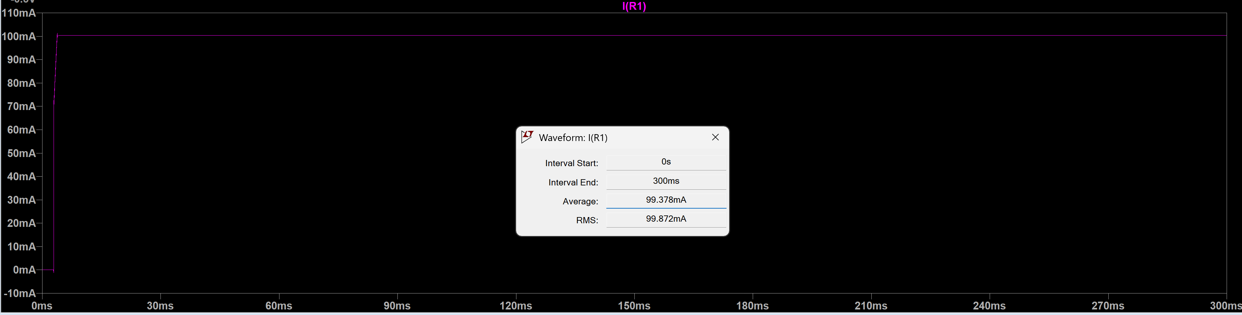
Figure 8: Regulated Current Output for 100mA (Simulation)

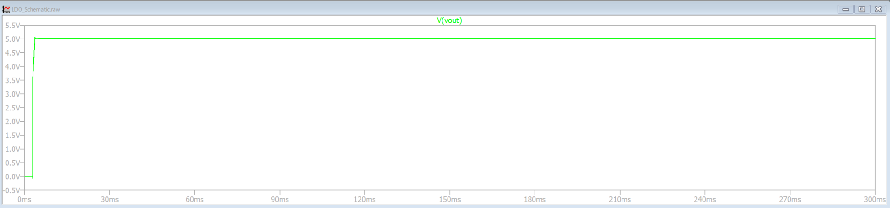
Figure 9: Regulated Output Voltage (LDO Output) of 5mA Output

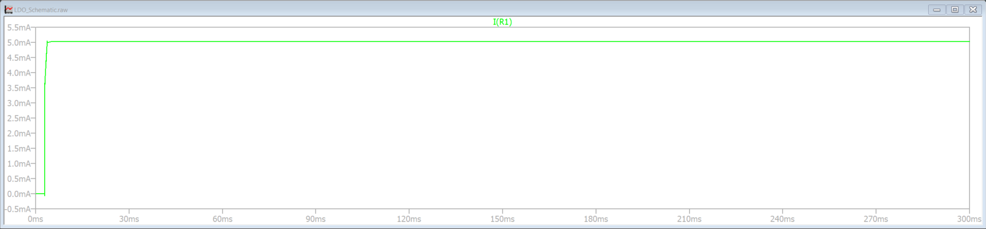
Figure 10: Regulated Current Output for 5mA (Simulation)

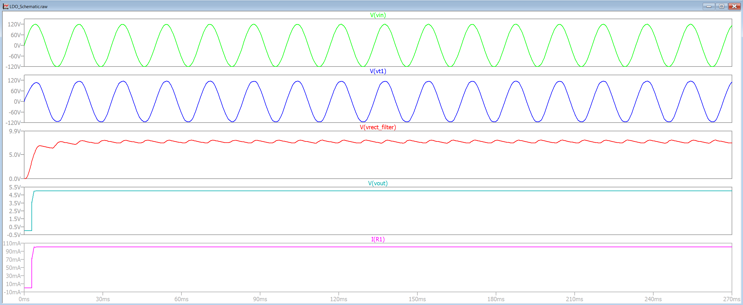
Figure 11: All Readings in the Same Plot for the Unregulated Voltage Output Circuit

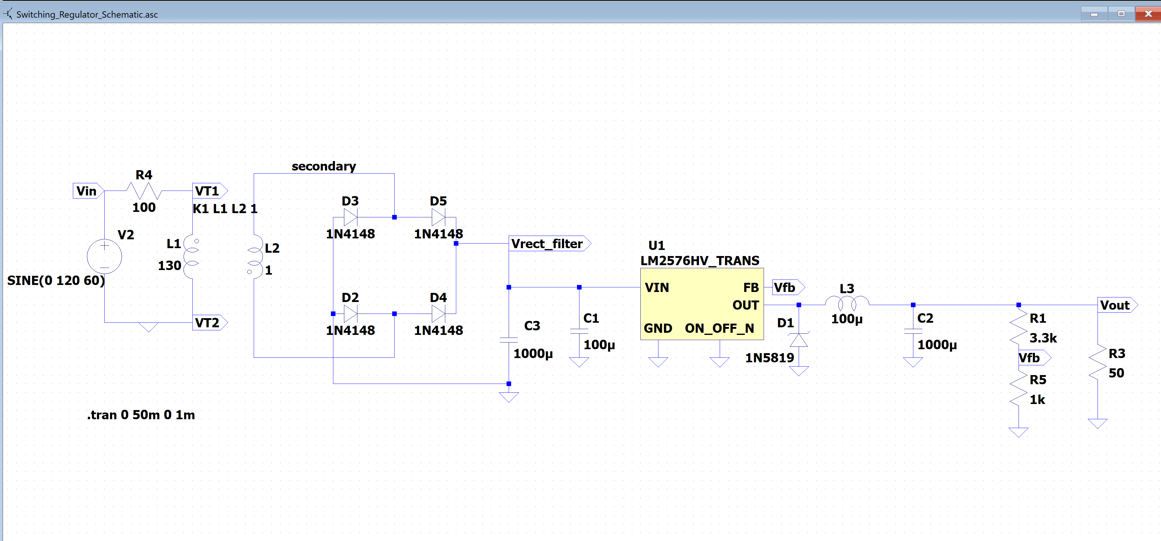
Figure 12: Switching Regulator Circuit

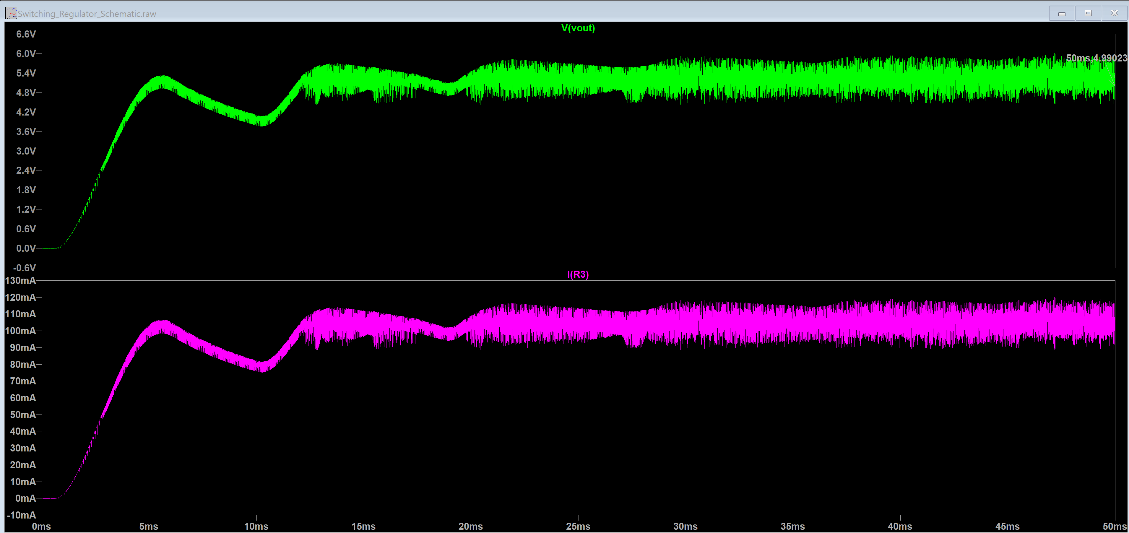
Figure 13: Switching Regulator Output Current and Output Voltage Plots for I = 100mA

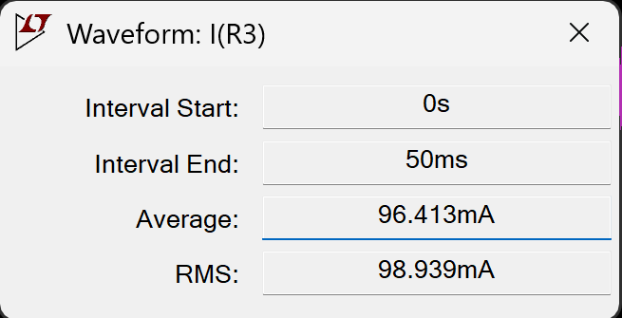
Figure 14: Image of Current Output for Switching Regulator (Simulation)
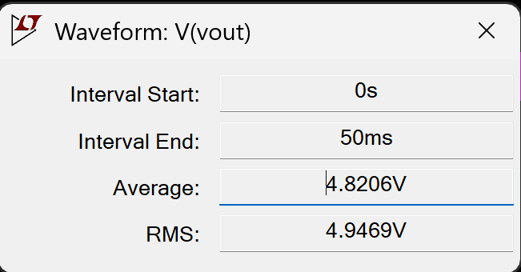
Figure 15: Image of Voltage Output for Switching Regulator (Simulation)

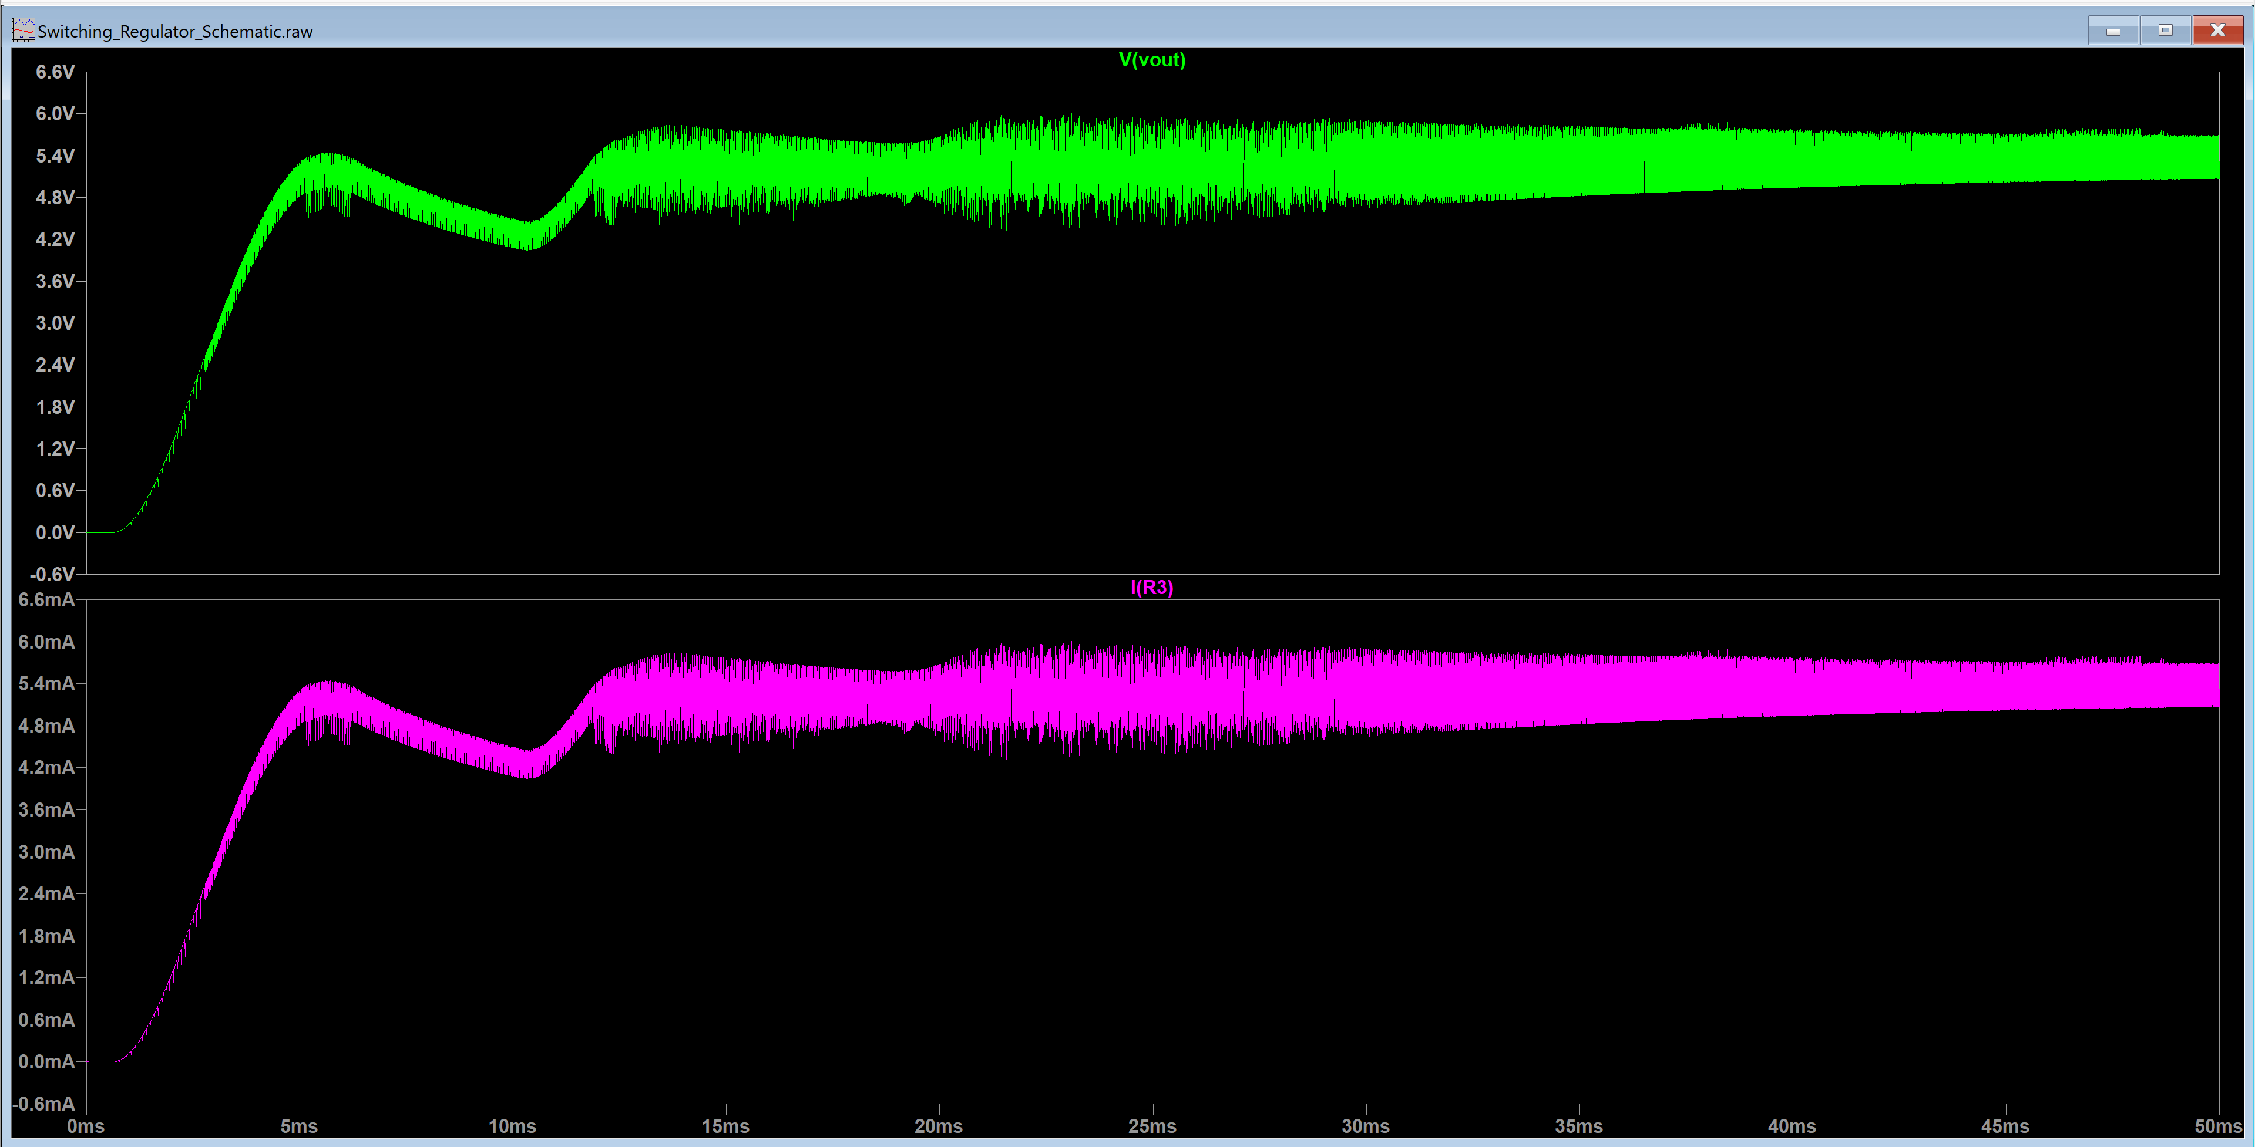
Figure 16: Switching Regulator Output Current and Output Voltage Plots for I = 5mA

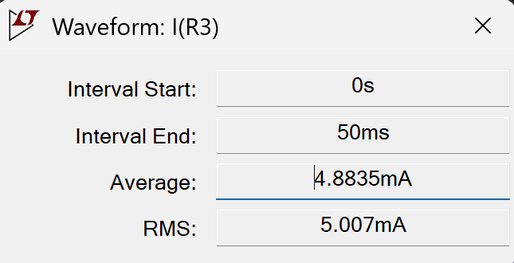
Figure 17: Image of Current Output for Switching Regulator

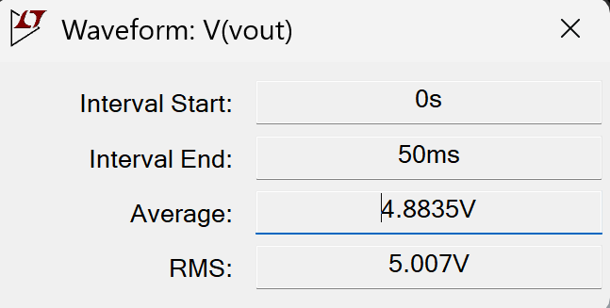
Figure 18: Image of Voltage Output for Switching Regulator

Conclusion
The conclusion should reiterate key points learned in this module.

References
Put the references in any standard citation form here. Websites are allowed. (This is your chance to learn more about LDOs, Zener diodes, switching regulators, etc.)
Zotero is an excellent open-source citation/reference manager. With very few clicks it will generate a bibliography for you and it is very easy to import refences into the software.

